Sand Slime:
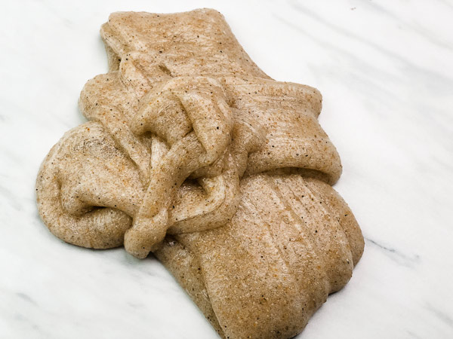
Ingredients:
1 airtight container
1 5 oz bottle of clear glue
½ cup water
½ tsp baking soda
1 tbsp contact solution
Sand (I used a mix of 3 different colors of craft sand, but you can use play sand too. Just if it has rocks, sift through it to get the rocks and pebbles out.)
Small bowl
Instructions:
In a bowl, pour the entire 5 oz. bottle of clear glue.
Add in ½ cup of water.
Add in ½ tsp baking soda and stir.
Pour in some sand. You can always add more
Add 1 tbsp contact solution. It will instantly begin to form.
It will be STICKY! Don’t panic! Mix the solution in the bowl until it starts to form.
Knead the slime until it is no longer sticky.
Continue to add the sand until you get a look that you are going for.
Store in an airtight container.

