Sweet potato pudding
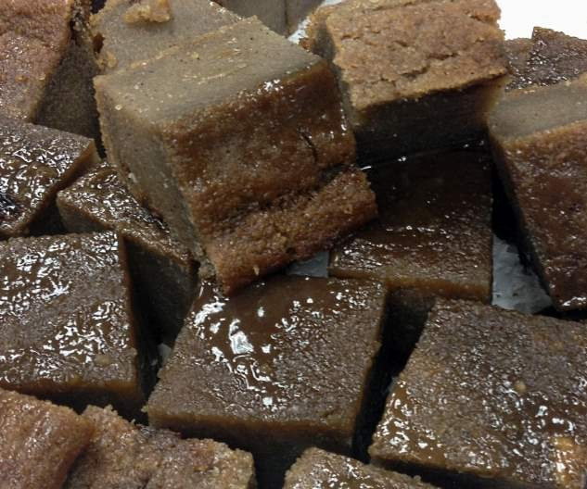

Ingredients:
2 pounds sweet potato (peeled, washed and grated)
2 cups coconut milk
1 cup flour
1 teaspoon mixed spice
1 1/2 teaspoon nutmeg, grated
1 teaspoon salt
1 1/2 cups raisins
2 teaspoons vanilla
1 cup brown sugar
1 teaspoon margarine

Directions:
Peel the potatoes and wash them well. Grate them using a food processor and keep them aside.
Prepare some coconut milk by grating some coconut, adding water to it and then squeezing its well.
Take a large mixing bowl and combine the flour with mixed spice and nutmeg. Sprinkle some salt and mix it well.
Add the grated potatoes to this mix, followed by the raisins, vanilla and sugar. Mix to combine them well.
Drop in some butter or margarine and give it a gentle stir.
Once done, grease the baking pan and pour the batter in it. Let it bake for an hour at 350 degrees. Keep checking for doneness as the baking time might vary (pudding is ready when a knife when inserted at the center of the cake should come out clean).

