Limber de coco (coconut ice):
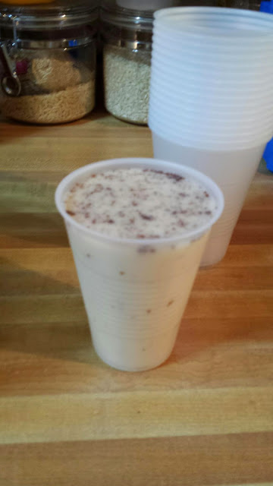
Ingredients:
Makes up to 5 9oz cups
12oz can of evaporated milk
13.5oz can of coconut milk
15oz can of cream of coconut
1 teaspoon of vanilla extract
1/2 cup of water
1/2 teaspoon of Cinnamon (optional)
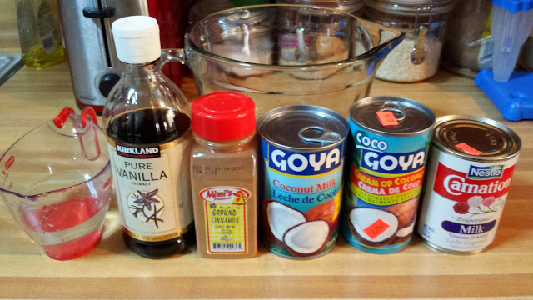

Tools:
Mixing bowl
Whisk or spoon
9oz plastic cups
Cookie sheet or baking pan
Freezer
Directions:
In a large bowl add all ingredients and mix well, place cups on a cookie sheet or baking pan place in freezer and pour the mixture into the cups. Freeze the limber’s for about 6 hours. And now enjoy!
