Fuzzy Koala Friend

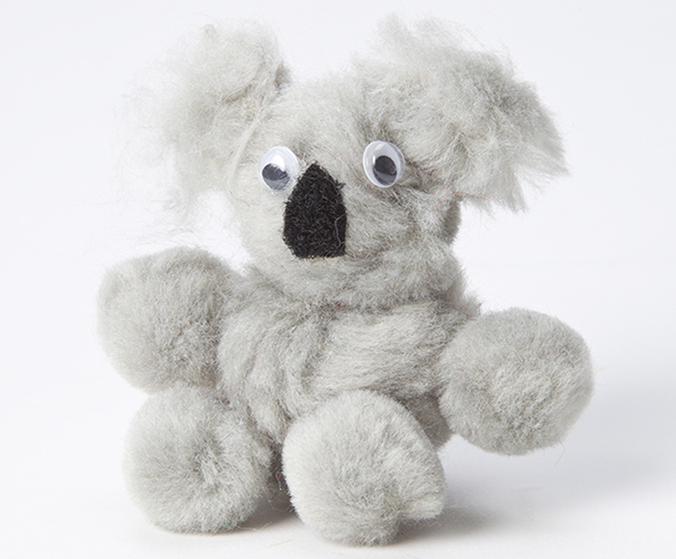
About: Create a fuzzy little koala out of pom-poms and felt

Materials:
- (4) 1-inch gray pom-poms
- (1) 2 ½ inch gray pom-pom
- (1) 2-inch gray pom-pom
- (2) ½-inch gray pom-poms
- (2) small googly eyes
- (1) small scrap of black felt
- White glue

Instructions:
- Glue the 2-inch pom-pom to the top of the 2-1/2-inch pom-pom. Now you have a head on a body.
- Glue each of the four 1-inch pom-poms to the body as arms and legs.
- Glue eyes on the “face”
- Cut a triangle shape out of the black felt for the koala’s nose and glue it to the “face”.
- Glue the two ½ inch pom-poms to the sides of the head for ears.
- Set your fuzzy friend in a safe place to dry.
