Answers
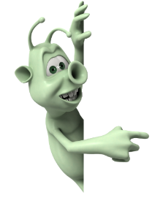
- What is the famous river that flows through Egypt?
-Nile ☺
-Ganges
-Thames
-Amazon
- When was the Ancient Egyptian time period?
-30 BCE to 1000 CE
-3150 to 30 BCE ☺
-30 BCE to 2000 CE
-1069 to 30 BCE
- What would you find inside a mummy?
-Beetles
-Organs
-Bandages
-Sawdust ☺
- What are the names of the symbols that represent letters or words?
-Wall doodles
-Cave paintings
-hieroglyphics ☺
-Etchings
- Which animal did the Egyptians love?
-Cats ☺
-fish
-ponies
-dogs
- Did the Egyptians make boats of out reeds?
-No
-Yes ☺
- Who was the last ruler of Egypt?
-Caesar
-Cleopatra ☺
-Theos
-Tutankhamun
- What was the name of the giant sculpture that was half man and half cat?
-The Great sphinx of Giza ☺
-the big cat of Egypt
-the missing nose
-The Mona Lisa

